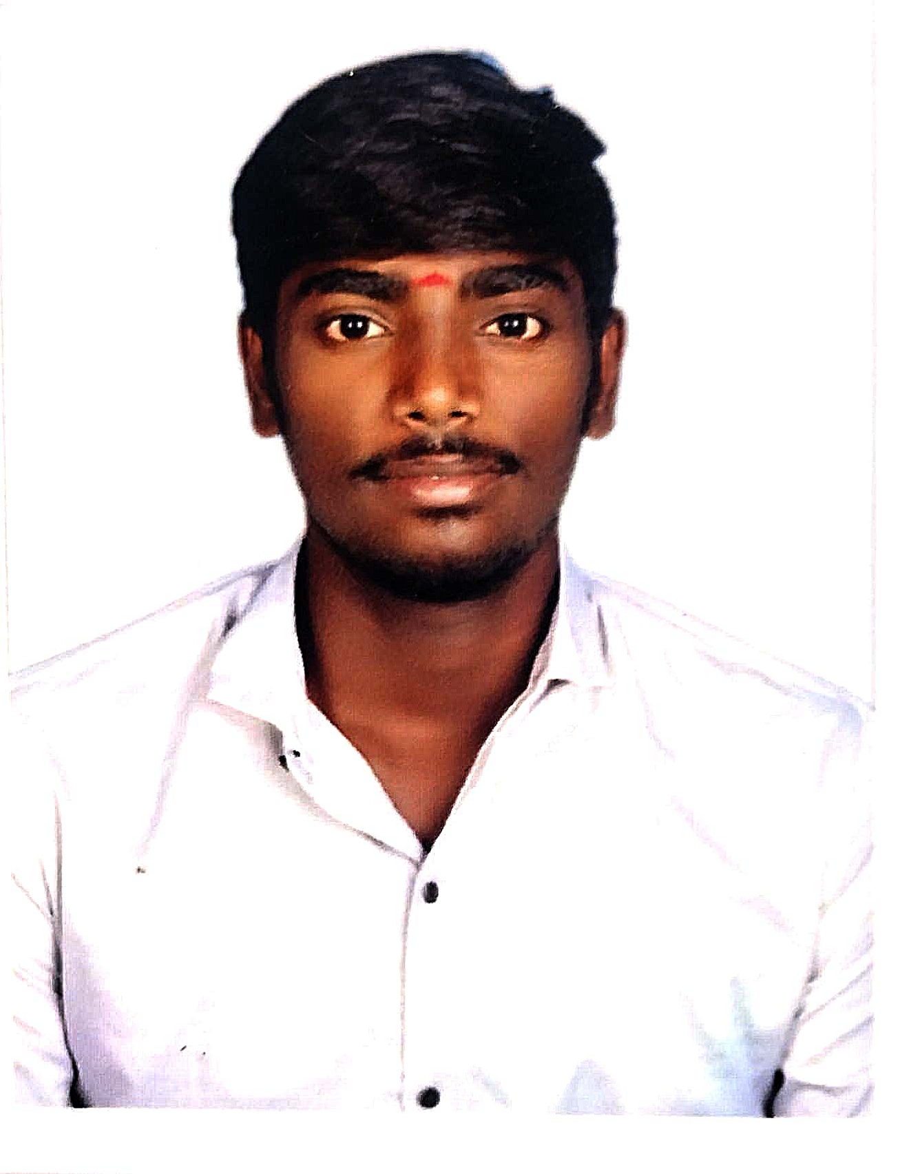**MANIBALAN A**

Thanjavur(DT),Kumbakonam | [amanibalancse@gmail.com](mailto:amanibalancse@gmail.com) | 9942626736 | [https://www.linkedin.com/in/amanibalancse](https://www.linkedin.com/in/amanibalancse/) | <https://github.com/ManiBalan-777>

**PROFESSIONAL EXPERIENCE**

Computer Science graduate skilled in React, Java, and SQL, with a proactive approach to learning and problem-solving in real-world application development.

**SKILLS AND CERTIFICATIONS**

* **Technical Skills:** Git, GitHub, HTML, CSS, JavaScript, Bootstrap, React (Basic), Java, Collections, Data Structures, Servlets, DB Connectivity, SQL (MySQL), C Programming, Microsoft Office (Excel, Word, PowerPoint)
* **Soft Skills :** Problem-solving, Debugging, Logical Reasoning, Communication,Time Management, Team Collaboration, Adaptability, Quick Learning of New Technologies, Attention to Detail
* **Courses and Certificates:** Certified in Frontend Development (Smart Cliff Learning Solutions),AWS Cloud Computing in ICT Academy, Java Basics (Great Learning), and Oracle Cloud Computing (IBM). Also certified in Microsoft Office Suite (Excel, Word, PowerPoint, OneDrive, SharePoint).
* **Languages**: English ,Tamil

**EDUCATION**

**Government College of Engineering,** Sengipatti, Thanjavur

Bachelor of Engineering,Major in Computer Science **2021-2025**

CGPA: 8.07/10.0

**Gokilambal Matriculation Higher Secondary School** Kuzhavadaiyan, Anaikarai

Higher Secondary Certificates(HSC) **2020-2021**

Percentage: 94%

**PROFESSIONAL EXPERIENCE**

**Smart Cliff Learning Solutions** Coimbatore

Front End Development InternshipJuly 2024 – Aug 2024

* Developed a responsive, user-friendly job portal frontend using HTML, CSS, Bootstrap, and React to enhance accessibility and performance.
* Implemented dynamic features with JavaScript, optimizing code for better load times and user engagement.

**SSRTIC** Paapanasam

Web Development Training (HTML, CSS, JavaScript, DB Connectivity, MySQL, Java)

* Developed responsive web pages and interactive features using HTML, CSS, JavaScript, and integrated MySQL for database connectivity.
* Built a small-scale web project combining frontend and backend technologies, strengthening problem-solving and technical skills.

**PROJECTS**

**JOB PORTAL APPLICATIONS** July 2024

* Developed a responsive job portal interface using HTML, CSS, and Bootstrap to ensure seamless user experience across devices.
* Implemented dynamic features with JavaScript and integrated React to create reusable components, manage application state, and enhance interactivity for job seekers and recruiters.

**STUDENT RESULT MANAGEMENT** Sep 2023

* Developed a student result management system that allows students to view their results by entering their register number and date of birth, utilizing frontend technologies for an intuitive user interface.
* Implemented Java Servlet for backend processing to retrieve and display results from the database, ensuring efficient data storage and retrieval in NetBeans IDE.